What Is the Fibonacci Sequence?

The Fibonacci sequence, named after Italian mathematician Leonardo of Pisa, is a sequence of numbers where every number after the first two numbers is a sum of the proceeding numbers. Let’s take a look below.

Fibonacci Sequence:
1, 1, 2, 3, 5, 8, 13, 21, 34, 55, 89...

Such that:
1 + 1 = 2;
2 + 3 = 5;
3 + 5 = 8;
8 + 13 = 21;
13 + 21 = 34;
21 + 34 = 55;
34 + 55 = 89;
and so on to infinity

كل عدد في هذه المتتالية (باستثناء العددين 0 و 1) هو ناتج العددين الذين يسبقانه، ويمكن تعريف هذه المتتالية رياضيًا باستخدام العلاقة التعاودية التالية:
Fn = Fn-1 + Fn-2

أما العددان 0 و 1 فيكونان ثابتين دائمًا:
F0 = 0 and F1 = 1

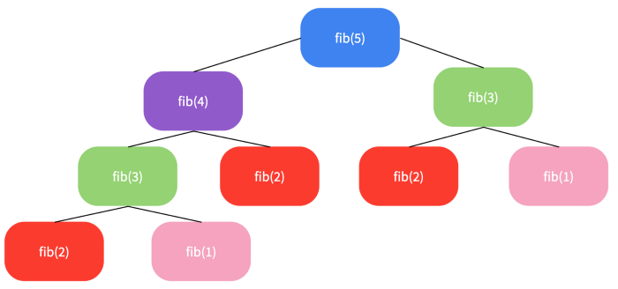
We can think of the numbers as a tree-like data structure. If we structure the sequence into a tree, we can calculate the Fibonacci value of any number at that position.

يمكننا أن نرى أن
fib (1) ، fib (2) ، fib ( 3)
تتكرر عدة مرات.

la solution :
LA factorisation

